Advanced Games Programming
Tutorial 10 - Additional Exercises
Make sure you save all your code, and any other important files often. If you are working on the desktop, back up to the U: drive. It's very possible to crash the display driver when playing with shader files.

Advanced

Name advanced exercises Tutorial xx Advanced yy, using appropriate xx and yy.

Advanced Exercise 01

A more robust and general lighting system might involve creating a LightManager class that contains all the lights in the scene, which is then used by the Model classes to query for the appropriate lights. For example, imagine there are 100 lights in a scene, and your shader can only handle up to 8 lights - in this case the Model class might query the LightManager for the nearest 8, or perhaps the most important lights and then the nearest ( e.g. always include a directional light for sunlight, then 7 nearest others). Design and implement your own LightManager class, and update your Model class to use it.

Advanced Exercise 02

The object loader objfilemodel provided for this tutorial only copes with .OBJ files that were exported as triangle only meshes. The code that deals with faces starts on line 136 of objfilemodel.cpp, and uses a quick method of counting the number of forward slashes on a line, as well as checking to see if there are any adjacent slashes, in order to determine what vertex elements need to be read (texcoords, normals or both). This simple algorithm doesn't cope with more than three vertices for a face.

The .OBJ format specifies that any face should be flat and convex in shape, and any flat convex polygon can be broken easily into triangles using a triangle fan, e.g.:

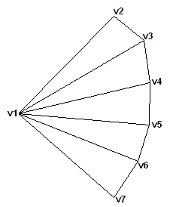

Update the loader to cope with 3 or more vertices in any given face. You will need to change the parsing of the line to detect what vertex elements are needed in a different and more robust way, and that can parse any number of vertices to correctly separate the polygon into multiple triangles.

Advanced Exercise 03

The object loader objfilemodel provided for this tutorial also does not deal correctly with objects that have multiple textures and materials applied. You will need to do some research into how textures and materials are represented in .OBJ files, then update the file loader to take this extra information into account when loading a model. You will also need to make changes to the model class to store any the additional textures, and major changes to your shaders to deal with materials and multiple textures (for instance, consider how you might handle an unknown number of textures?), as well as the appropriate changes to the setup for the drawing method.

